Group 3354 TechRock Detailed Design Document
Nathan Cox, Madie King, Quincy Bright, Kuangchi Chen, Jin Kim, Zhixuan Yang

Contents
Terminology 3
Introduction 3
Background 3
Document Summary 4
System Architecture 4
Static System Architecture 5
Dynamic System Architecture 6
Data Storage Design 7
Introduction 7
File Use and Data Exchange 8
Security Concerns 8
Component Design 9
Static Component Design 10
Dynamic Component Design 11
UI design 12

Figures
Figure 1 Static System Architecture Diagram 5
Figure 2 Dynamic System Architecture Diagram 6
Figure 3 JSON Data Examples 7
Figure 4 Column Fields Example 8
Figure 5 Static Component Class Diagram 10
Figure 6 Dynamic Component Sequence Diagram 11
Figure 7 Application Main Page 12
Figure 8 Application Graph Selection 13
Figure 9 Application Line Chart 13
Figure 10 Application Pie Chart 14
Figure 11 Application Bar Chart 14

Terminology
AG Grid: A data grid component designed to work with JavaScript frameworks, including React.
Aladdin: BlackRock’s portfolio management software. Our app is meant to interface with this software to retrieve the tabular data.
Axios: A HTTP client for node.js that we are using to pass data to the AG Grid.
D3: The JavaScript library we are using to generate our graphs and charts.
Postman: An API platform we were using to generate our mock data. Our client eventually directed us to a better option, this is obsolete.
JSON Mock Server: Our client helped set up a custom JSON mock server, which is where our development data was stored and accessed. This replaced postman.
React: A library used in the creation of our user interface. The segments of the interface created with react are called components and they are written in JavaScript.

Introduction

Background
The TechRock project is a web app being developed for our client BlackRock, an asset and investment management firm. Their tech platform Aladdin is a large tabular library, and our application is intended to allow them to import data from Aladin and generate a graph for it. These visualizations attract attention, can help users understand the data presented quicker, and stick in the memory of users. Our solution was to create a data agnostic web application that BlackRock developers and bankers can upload an Aladin endpoint to, and then manipulate to generate a graph that they can use.

Document Summary
In this document, we’ll go over the overall design of the project, covering the system architecture, data storage, component, and UI design. In System Architecture, we discuss the rationale behind our architectural choices, diagramming the static and dynamic elements of the system. In Data Storage, we illustrate our approach to mimic the database we’re interfacing with through mock servers and discuss file use and potential security concerns. In Component Design, we build off the presented system architecture design and show static and dynamic representations of the components of our system. Finally in UI Design, we show the major screens of our final product, show how to navigate within the app, and relate the design back to the design principles we learned earlier in the class.

System Architecture
Our App is a desktop application that will interface with existing Aladdin APIs and generate graphs based off that data. However, most of the data that Aladin uses is confidential, meaning we will not have access to it throughout the development process. For this reason, we are utilizing JSON mock servers to develop an application that is compatible with as many different data sets as possible. We initially started running these servers via Postman, but eventually ran these servers locally when we exceeded Postman's capacity. For this reason, we chose to use a layered architecture with a robust interface and application logic layer, that can interface with any given database. The following diagram demonstrates how our application interfaces with both the mock servers and the final Aladin server.

Static System Architecture
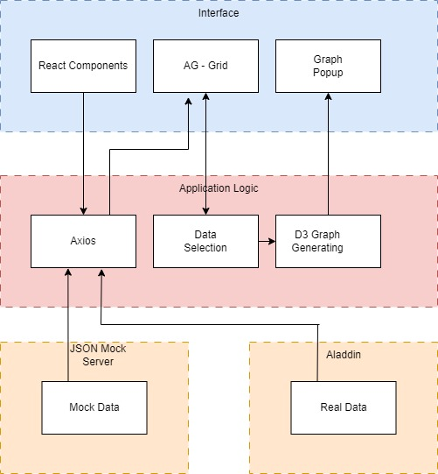
Figure 1 Static System Architecture Diagram
This diagram uses 3 layers. The interface layer starts with the React components, which initially have no data, they make a call to the application logic layer which employs Axios to call to the data layer. The data layer here is split into two components as the data we are using for development will not be the final product data, and thus must be generalized to be as broad as possible, so that any data from the Aladin component can be used. The Axios call then passes the data back up to AG-Grid, a react component. The react component then has features implemented that allow for specific data, either by column or index to be selected. This reduced data then gets passed to D3, which generates a specified type of graph based on the selected data. This then gets passed back up to the interface level with a popup window with the graph generated. This structure allows for all the graphs to be generated with only a single call to the backend, allowing for the most flexible implementation based on our limited access to BlackRock resources.

Dynamic System Architecture
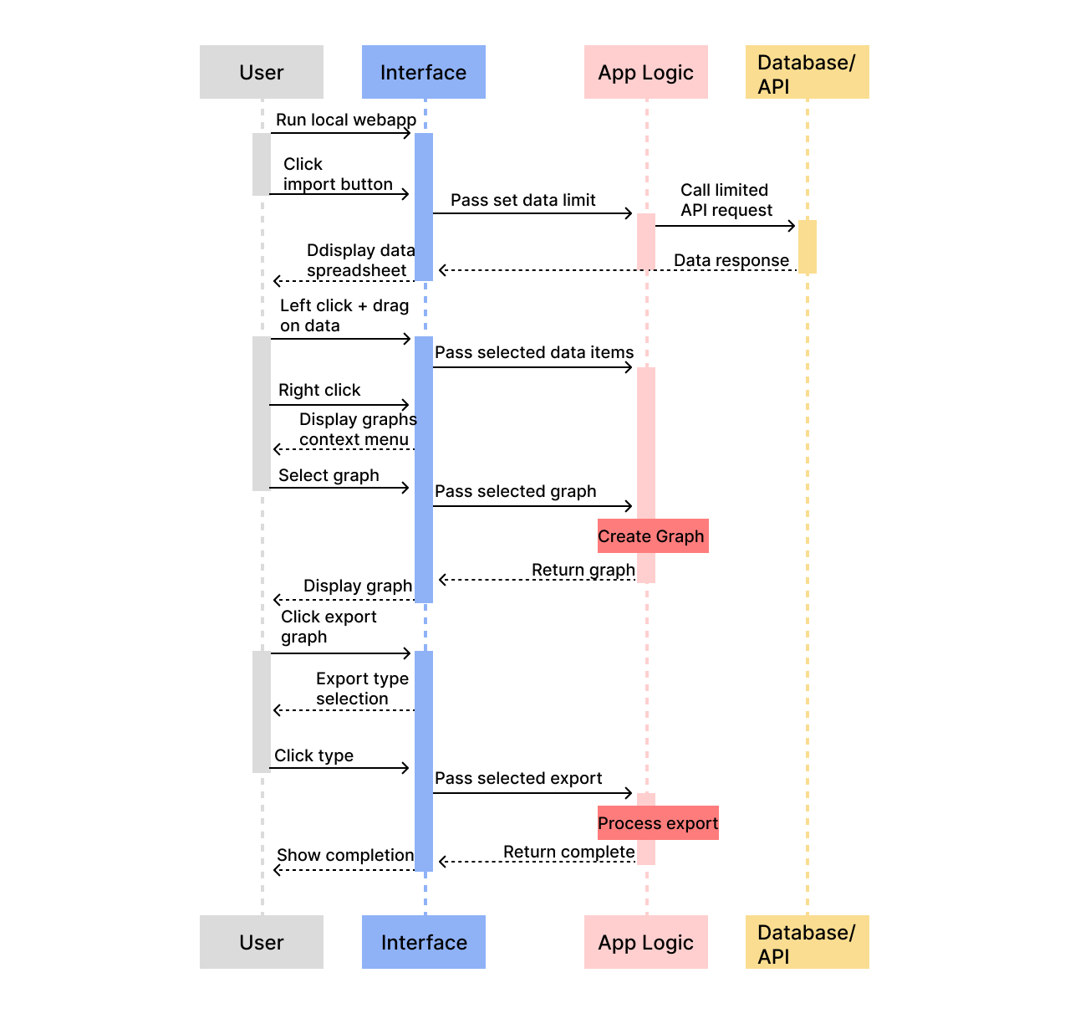
Figure 2 Dynamic System Architecture Diagram
This is the dynamic system architecture for basic utilization of our application. There are four levels: User, Interface, App, and Backend. The bulk of our applications function lies in the front-end interface and how it interacts with the user. Upon running the local web-application, the user can click to import data into the application which passes the data limit to through the app logic and initiates a backend request. The data is then returned through the interface and displayed to the user. The User can then select data by using the Ag Grid column filter function to narrow the range of data passed to the grid, and then they can set the specific column represented by different graph parameters using dropdown menus in the graph popup. Upon right clicking on selected data, the user is shown a context menu to select a graph type to generate. Once a type is selected, the data and graph type are used to create a graph returned and shown to the user. With the newly created graph, the user can click to export the graph, which will automatically export the graph as a JPEG file.

Data Storage Design

Introduction
In the context of our project’s data storage design for data visualization, we don’t utilize any relational database, and our mock data is generated by JSON mock servers, formerly postman and currently a local server. This is done for the purpose of emulating the real financial data, which due to BlackRock policy, we will not have any access to.
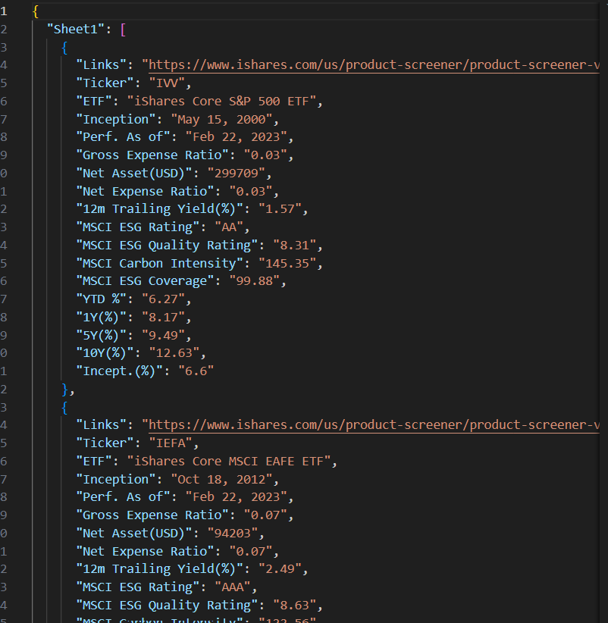
Figure 3 JSON Data Examples
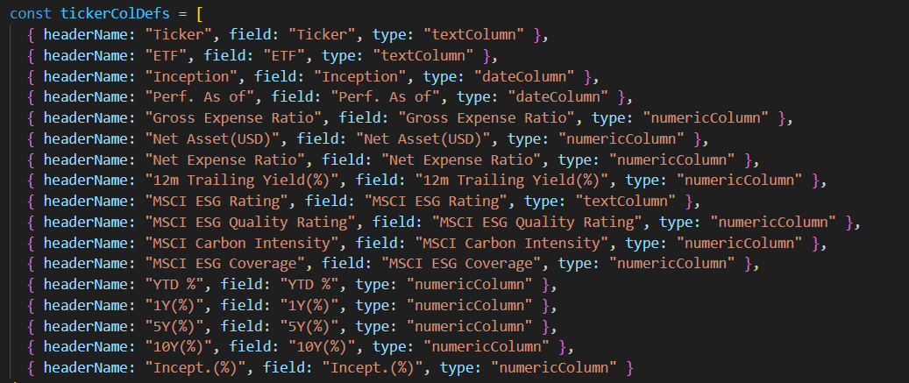
Figure 4 Column Fields Example
These are the examples showing how our mock data and column fields are managed. The key numbers in Figure 3 are just the default indices, referring to different “Tickers”, and each ticker is displayed as a row in our project. Our users can copy and paste their data link into the textbox in the front-end, then the data will be read and extracted for later visualization purposes. While we do not employ a traditional relational database, we adhere to effective data organization principles, presenting an illustration of the JSON document structure and its fields as Figure 4, assisting us to better distribute and visualization the data. This JSON-type data seamlessly integrates into our web application through the implementation of ag-Grid. The ag-Grid implementation enhances the user experience by enabling features like sorting, filtering, and grouping for efficient data analysis.

File Use and Data Exchange
Our project does not involve file use. This is a stretch goal and is not expected by our client in this project. Data exchange will be involved when our app comes into use because our users are Blackrock employees, and they need to transfer their data from Aladdin to our app. However, in this project, we will not get access to their data. We are only building our app based on our mock data; thus, no data exchange needs to be considered.

Security Concerns
In terms of security concerns, since we do not save user’s data in any way, we believe there is no potential privacy leak. Our client has a robust, integrated suite of applications like this, and as such expects a simple front-end package that they will integrate into their existing system. Therefore, our concerns are mainly from the perspective of app development. In the front-end, we have a textbox where users type in the link of their JSON data. Even though we believe that our app is only for internal use, the link sources should be safe enough, there are still potential concerns. If the data happens to embed any malicious URLs or scripts, and it happens to be compiled or executed in the back end when we try to call some packages, JavaScript injections such as XSS (Cross Site Scripting) can occur. Additionally, if the link itself is somehow malicious, since our app does not have a filter, unrestricted file uploading may exist too. However, these concerns are based on a lack of familiarity with our real data. This is an app that, once we handoff, will be integrated into an existing security system, and so we have been told not to focus on this aspect.

Component Design
This section's purpose is to take the system architecture laid out previously and expand on it, visualizing our system on a component level. For both diagrams, we maintain the idea of having three distinct layers: the user interface, application logic, and database/mock server. In the visualizations, the Aladdin database and mock server are treated as the same entity, but the idea behind that is that the mock server will be used for testing during development and is structured in a way that the final program will be able to interact with the actual database in its place. It is implied that all UI processes are implemented through React components and the graph generation is done through D3.

Static Component Design
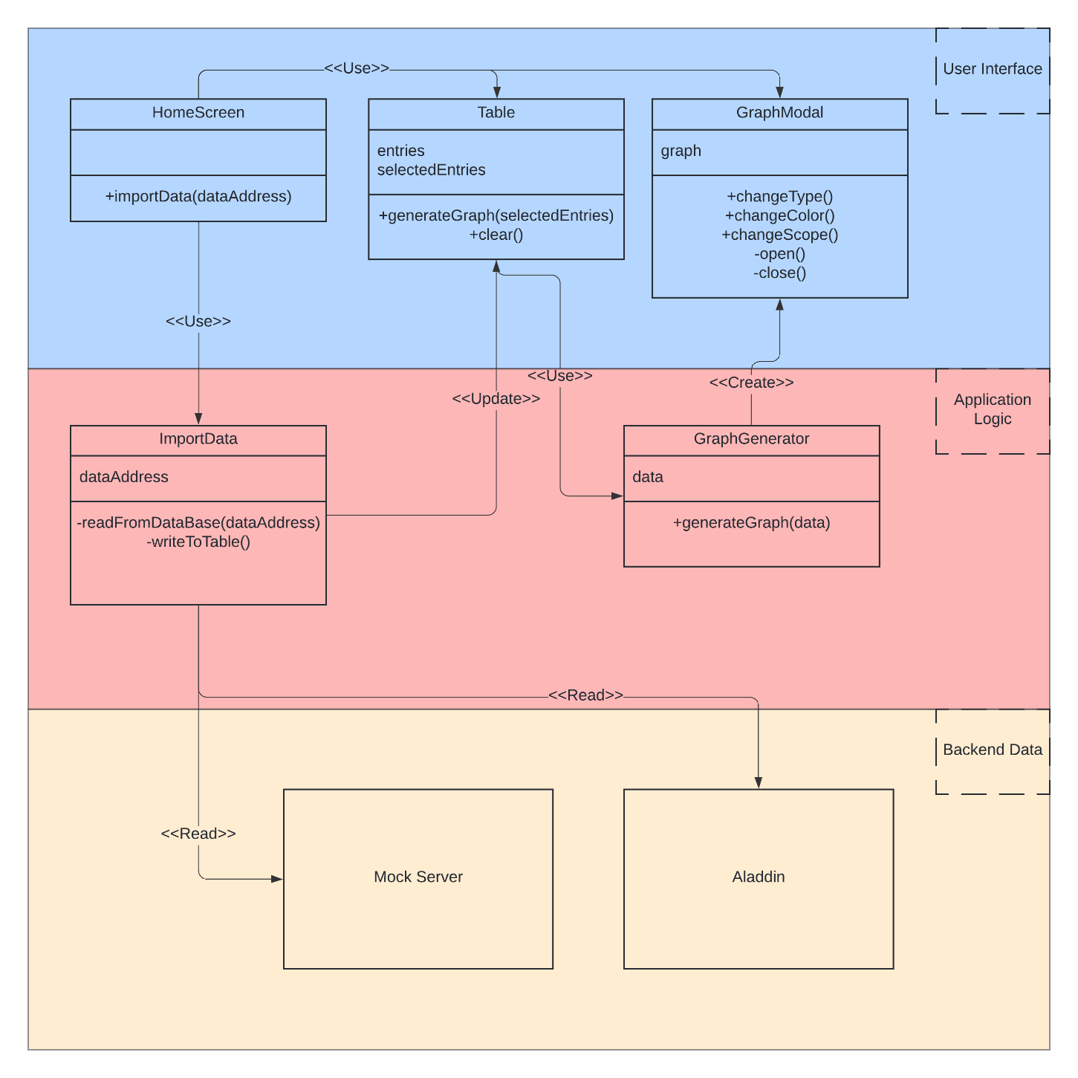
Figure 5 Static Component Class Diagram
This simplified class diagram shows theoretical classes that are meant to show the inner workings of our system. Just like the static system architecture counterpart, this diagram is color-coded to show which class falls into which layer. Blue is the user interface section, red is the application logic section, and yellow holds the Aladdin database / mock server. This diagram is meant to focus on how the different components of the system are built to interact with each other, whether they are simply used or interfaced with by another component or if they read to/write from each other.

Dynamic Component Design

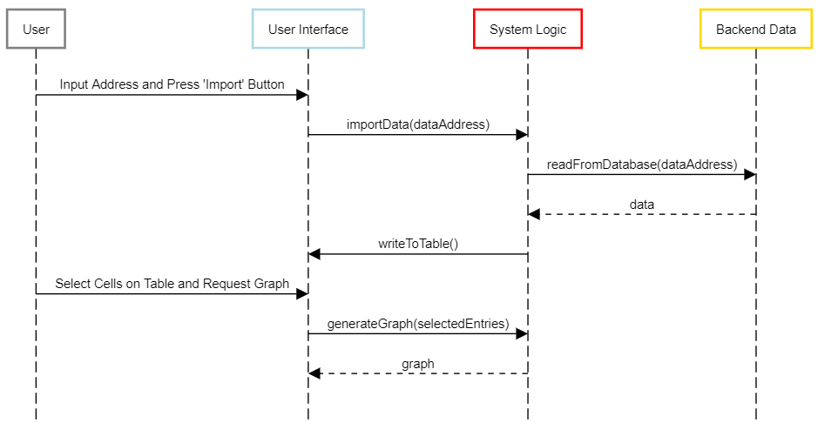
Figure 6 Dynamic Component Sequence Diagram
We decided to represent our dynamic component design by using a sequence diagram. The use case being explored here is a use deciding to generate a graph. It is chronological from top to bottom. First, a user must use the data import part of the upper toolbar and then the address given is passed to the system. It uses this address to pull the data from the backend database and then display it on our tabular display. Once this is displayed, users can click on cells within the table to select them and then use a dropdown menu to pass the data to the graph generator which will open a window displaying the desired graph.

UI design
In this section we present the UI (User Interface) of our site, which users will use when they want to generate different type of graphs and analyze them. This section will include the major pages of our site that users will interact with.
When the users go to our website, they will be shown the main page, which is displayed below.
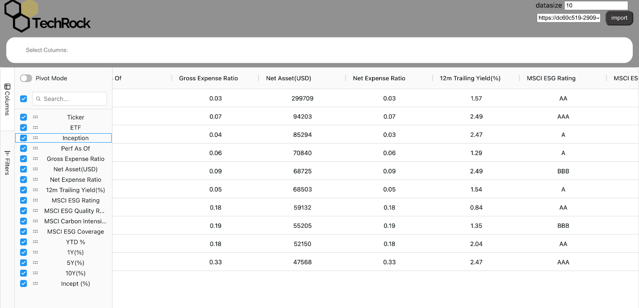
Figure 7 Application Main Page
In the main page, we use simple design choices. The application is based on the graphs generated, so the components are chosen to mimic existing spreadsheet software and readily provide the user with what tools are available to them. We have a box where users can paste in the link to their data and an import button where users can import their data. Much of the main page is composed of the data the users import because data is the most important part of the site. We provided a data filter function for our users on the left of the data section where our users can choose to filter specific parameters of the data, which provided flexibility to our users. This layout allows for the user to immediately see what tools are at their disposal and get immediate feedback when those tools are used.
Next, our users can select certain rows and generate different types of graphs based on their selected data. 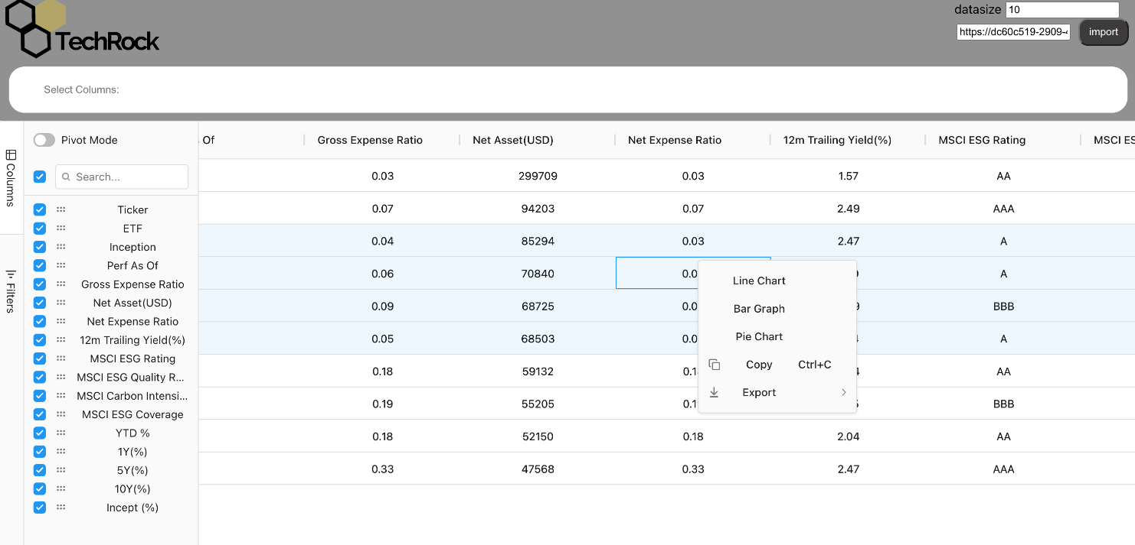
Figure 8 Application Graph Selection
After the users select the type of graph they want and click the button, the graph will be generated, and we can generate .png file by clicking on export button. The UI is designed to be as simple as possible, allowing for a simple workflow from data to graph. The customization options allow for additional features and control without interfering with this flow.
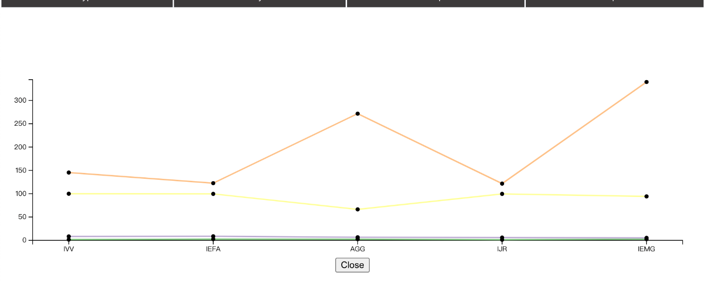
Figure 9 Application Line Chart
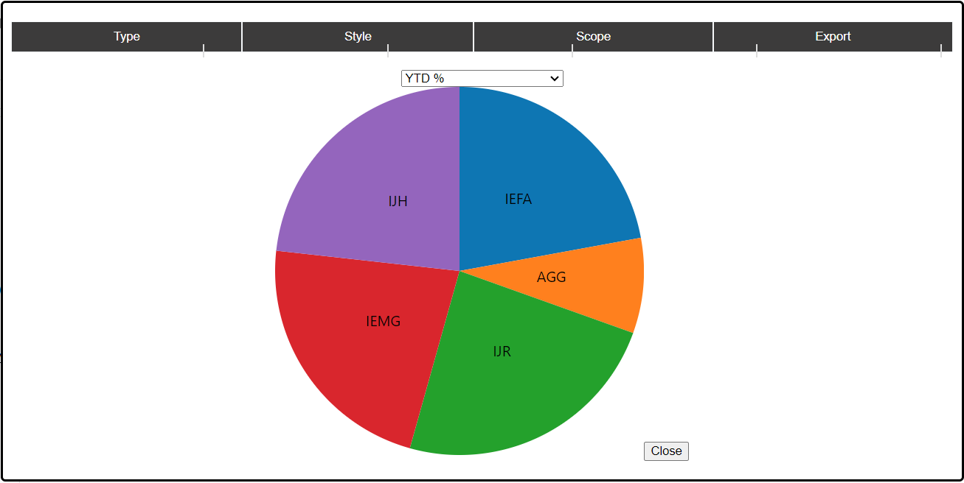
Figure 10 Application Pie Chart
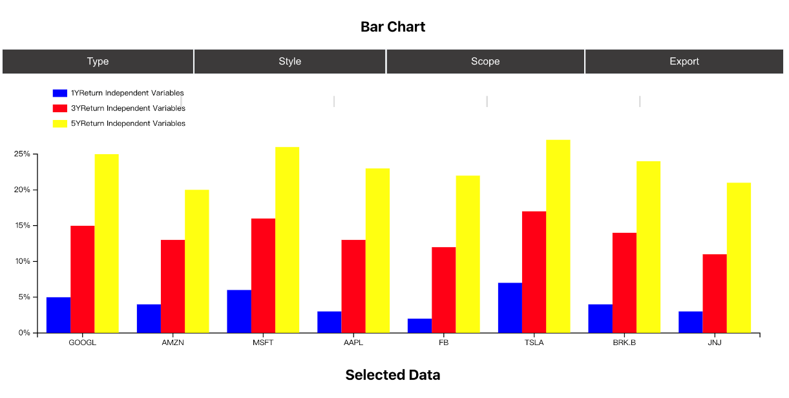
Figure 11 Application Bar Chart
Overall, the UI for our project is simple and easy to understand, because our users are all data analysts and bankers, so the functionality should be the focus.

